Math E-3 Assignment 7

If you use the Microsoft Word version to do the homework, make sure to view the pdf version to ensure that you have all the correct figures.

Z scores
Please show your normal distribution curve. Refer to z score tables at the end of the homework assignment to answer problems 2 and 3.

Problems 1-3

In a given population of males it is found that the mean weight is 170 lbs. Furthermore, the calculated standard deviation is 20.4 pounds. Assume the distribution of weights is normal.

- Draw the curve of the normal distribution of male weights.

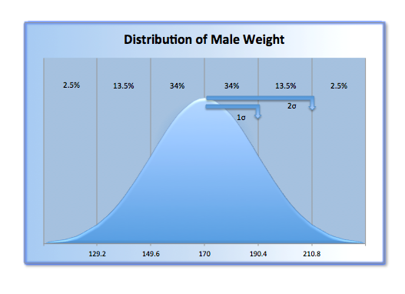

- Use the Z score tables at the end of the assignment to calculate the percentage of males who have weights between 140lbs and 170lbs.

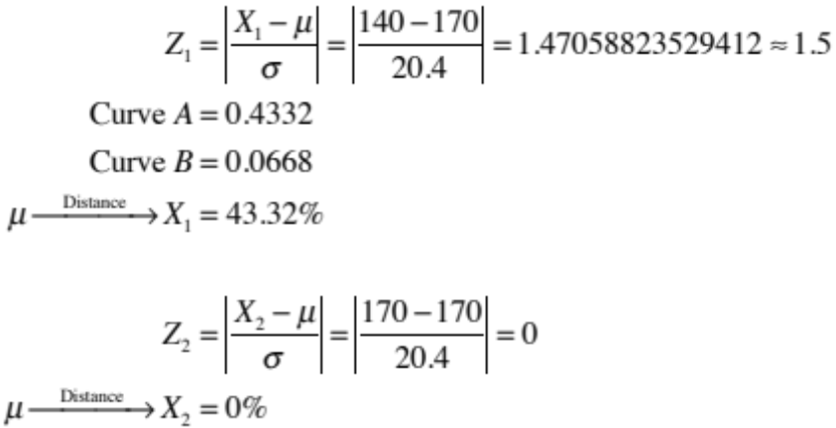

According to Curve A from 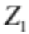, the percentage of males who have weights between 140lbs and 170lbs is 43.32%.

- Use the Z score tables at the end of the assignment to calculate the percentage of males who have weights between 155lbs and 195lbs.

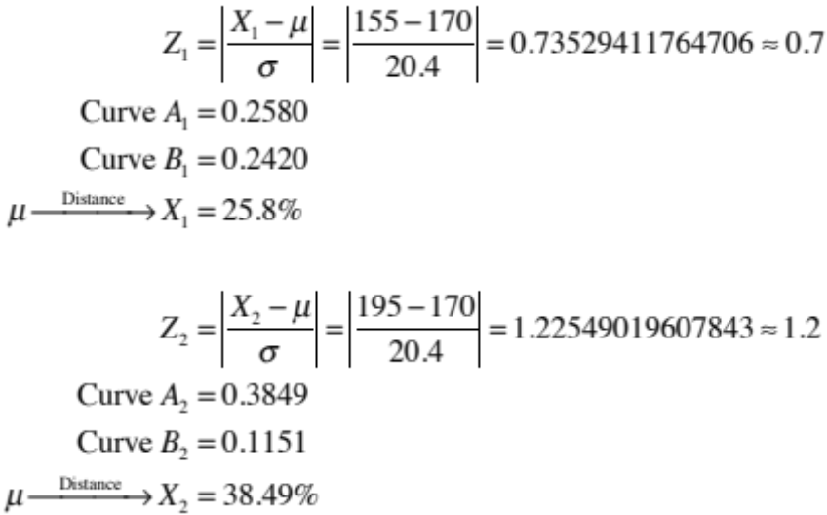

Since the point 155lbs is to the left of the mean (170lbs), and the point 195lbs is to the right of the mean, the sum of both of these distances will yield the correct percentage of males who have weights between 155lbs and 195lbs, i.e. 64.29%.

Problems 4-6

Suppose the scores on the Graduate Record Exam (GRE) are normally distributed with a mean of 500 and a standard deviation of 110.¹

4) Draw curve of the distribution of GRE scores.

5) If the graduate school you are interested in attending requires a GRE score of 630 for admission, how many standard deviations above the mean do you need to score?

6) If the admission's officer chooses and applicant at random, what is the probability of finding a student who scores a grade over 700 on the GRE? Use the z score table at the end of the assignment to help you answer this.

¹ Problem adapted from Using and Understanding Mathematics. Jeffrey Bennett, William Briggs. Addison, Wesley, Longman, 1998.

Hypothesis Testing

For problems 7 through 12, assume all samples were randomly chosen even if not stated in the problem.

Make sure you follow the steps as outlined in class and the reading; be sure to include a diagram for each question, and remember to clearly state both the Null Hypothesis and the conclusion in each case.

Follow this format for full credit for problems 7, 8, 9, 10, and 12:

Step 1) State your Null Hypothesis – use words not just a percentage.
Step 2) Calculate the Standard Deviation.
Step 3) Draw your diagram with the mean and 1 and 2 standard deviations identified.
Step 4) Calculate (if necessary), state, and compare the observed percentage.
Step 5) Construct the proper sentence either rejecting or not rejecting the Null Hypothesis. Use the proper statistical language.
Step 6) Give an informal conclusion.

Problem 11 does not require a new hypothesis test.

Problem 7

The Beautiful Body Cosmetics Company claims that its new wart cream dissolves
54% of all warts with one application. A scientist from a competing company is given
the job of disproving this claim. She purchases a few jars of the product and does her own tests. If this scientist tries the cream on several randomly selected people (and randomly selected warts!) and finds that after applying the cream to 300 warts, 158 of the unattractive warts disappeared with one application. Perform a hypothesis test and determine what the scientist would conclude about Beautiful Body’s product.

Problem 8 (This was an issue a few years ago, when Trent Lott was in the Senate)
Senator Lott claims that 50% of Americans want federal funding for PBS cut. You, a devout fan of “Barney” and “Lamb Chop” (sadly, Shari Lewis passed away in 1998), are deeply suspicious of this claim. So, you decide to take your own unbiased poll. You sample 250 people and find that 46% want to see the cuts in funding. Perform a hypothesis test, and give your conclusions.

Problem 9

You decide to take another sample of people to find out for sure about the public’s opinion on cuts to PBS, this time of 1500 people. From this sample, 700 folks favor the cuts. Perform another hypothesis test. What is your conclusion this time? If your conclusion is different than in problem 8 above, explain why there is a difference.

Problem 10

The Mars Company, maker of M&M’s, recently claimed that M&M’s were so much fun because they were a perfect rainbow, that is, each bag they made contained equal numbers of each of the five colors. An enterprising student decided to test this and bought several small bags selected at random, emptied them out and found that the number of M&M’s found for each color were:

Brown: | 128
Blue: | 87
Green: | 95
Orange: | 100 100 100 100
Yellow: | 90

Perform a hypothesis test and state your conclusions about Mars’ claim.

Problem 11
Refer to problem 10 above. If the colors were in equal numbers, what would be the probability that a random sample of 500 M&M’s will have the above proportion of brown ones? (Hint: Go back to the Normal Distribution Curve and look at the probabilities under the curve.) No need to perform another hypothesis test here.

Problem 12

A psychologist wants to test whether very young children are especially attracted to bright ‘crayon box’ colors. Thus, she places her young subjects in a playroom with three balls to choose from:

one is striped with black and white
one is made up of two assorted pastels shades
the last is striped with two bright primary colors.

The balls are identical in all other respects and their position is shuffled between trials so that it will not influence the results. From her observations she found that of the 80 toddlers she tested, 42 went for the brightly colored ball.

Formulate an appropriate null hypothesis as if you were the researcher, and perform a hypothesis test. (Remember that in hypothesis testing, you must have a proportion (percent) to work with. Think carefully about this percentage.) At the end, state your conclusion explicitly, i.e. do children tend to show a preference for bright colors?

Z -Scores*
Z =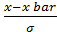 x bar=mean
A B

x bar x xbar x
Z | Area between the Mean and X (curve A) | Area beyond X (curve B)
.1 | .0398 | .4602
.2 | .0793 | .4207
.3 | .1179 | .3821
.4 | .1554 | .3446
.5 | .1915 | .3085
.6 | .2257 | .2743
.7 | .2580 | .2420
.8 | .2881 | .2119
.9 | .3159 | .1841
1 | .3413 | .1587
1.1 | .3643 | .1357
1.2 | .3849 | .1151
1.3 | .4032 | .0968
1.4 | .4192 | .0808
1.5 | .4332 | .0668
1.6 | .4452 | .0548
1.7 | .4554 | .0446
1.8 | .4641 | .0359
1.9 | .4713 | .0287
2 | .4772 | .0228
2.1 | .4821 | .0179
2.2 | .4861 | .0139
2.3 | .4893 | .0107
2.4 | .4918 | .0082
2.5 | .4838 | .0062
2.6 | .4953 | .0047
2.7 | .4965 | .0035
2.8 | .4974 | .0026
2.9 | .4981 | .0019
3 | .4987 | .0013
3.1 | .4990 | .0010
3.2 | .4993 | .0007
3.3 | .4995 | .0005
3.4 | .4997 | .0003
3.5 | .4998 | .0002
3.6 | .4998 | .0002
*Adapted from "Understanding Social Statistics, " by Jane Fielding and Nigel Gilbert.

